Customer Behavior Analysis
Project Report
Python EDA • SQL Analysis • Power BI Dashboard
Dataset: customer_shopping_behavior.csv

3,900  Customers | $233,081  Total Revenue | $59.76  Avg Purchase | 3.75  Avg Review Rating

Problem Statement

A leading retail company wants to better understand its customers’ shopping behavior in order to improve sales, customer satisfaction, and long-term loyalty. The management team has noticed changes in purchasing patterns across demographics, product categories, and sales channels (online vs. offline). They are particularly interested in uncovering which factors, such as discounts, reviews, seasons, or payment preferences, drive consumer decisions and repeat purchases.
You are tasked with analyzing the company’s consumer behavior dataset to answer the following overarching business question:
“How can the company leverage consumer shopping data to identify trends, improve customer engagement, and optimize marketing and product strategies?”

1. Executive Summary
――――――――――――――――――――――――――――――――――――――――――――――――――――――――――――――――――――――――――――――――
This project analyzes retail customer shopping behavior across 3,900 transactions and 18 attributes. The goal was to understand who is buying, what they buy, how they respond to discounts and subscriptions, and which products and customer groups contribute most to revenue.
The dataset generated $233,081 in total revenue, with an average order value of $59.76 and an average review rating of 3.75. Male customers contributed $157,890 in revenue versus $75,191 from female customers. Clothing was the strongest category, generating $104,264 in revenue.

2. Dataset Summary
――――――――――――――――――――――――――――――――――――――――――――――――――――――――――――――――――――――――――――――――
The dataset contains one row per customer purchase. It includes demographic fields, order details, customer engagement signals, and payment or shipping preferences.

Rows | 3,900
Columns | 18
Unique customers | 3,900
Total revenue | $233,081
Average purchase amount | $59.76
Average review rating | 3.75
Top revenue category | Clothing ($104,264)
Subscription mix | Yes 27% | No 73%

Main fields used in analysis included customer_id, age, gender, category, item_purchased, purchase_amount, review_rating, subscription_status, shipping_type, discount_applied, previous_purchases, payment_method, and frequency_of_purchases.

3. Exploratory Data Analysis in Python
――――――――――――――――――――――――――――――――――――――――――――――――――――――――――――――――――――――――――――――――

Python was used for cleaning, checking data types, computing descriptive statistics, grouping customers into segments, and visualizing patterns with pandas and matplotlib. The notebook also created an age-group feature using qcut so that customers could be compared across four balanced age bands.
Original notebook output used in EDA:

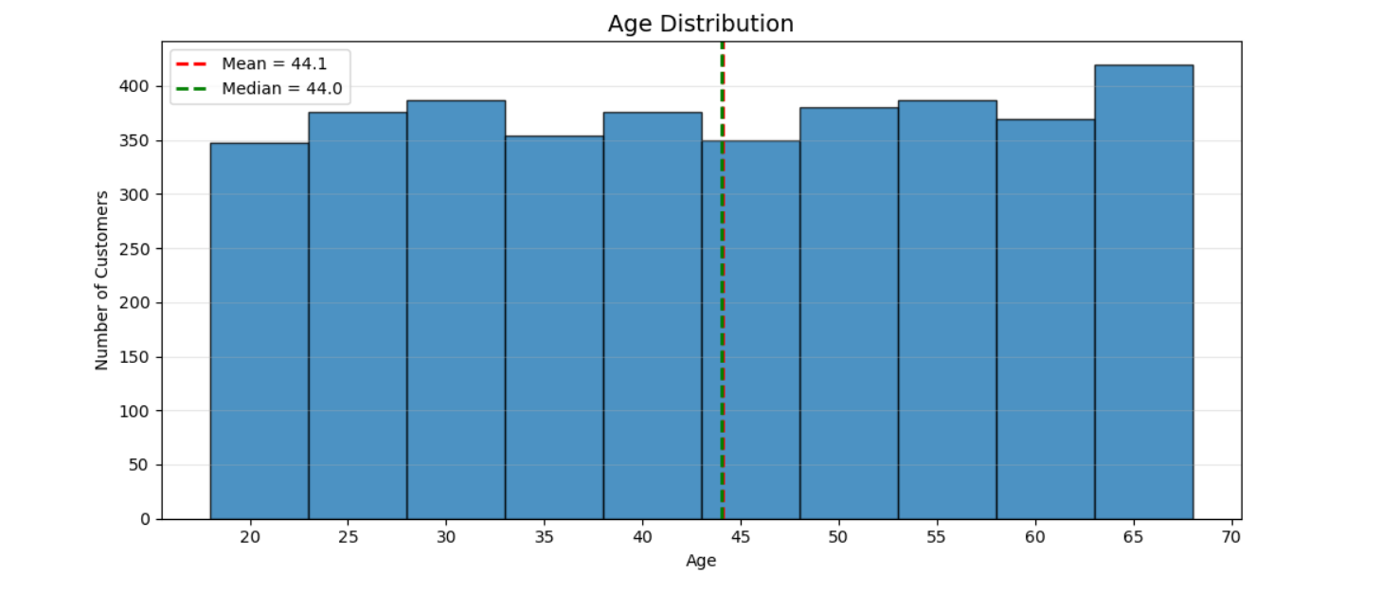
Figure 1. Notebook visualization output from the EDA workflow.

Key EDA findings:
• The purchase distribution was fairly broad, with spending spread across the full order range.
• Clothing and Accessories dominated both revenue and volume.
• Age groups were relatively balanced, but Young Adult customers showed the highest revenue in the qcut segmentation.
• Repeat purchase behavior was important for identifying loyal customers and potential subscription growth.

4. SQL Analysis and Business Questions
――――――――――――――――――――――――――――――――――――――――――――――――――――――――――――――――――――――――――――――――
SQL was used to answer practical business questions about revenue, product performance, customer retention, and discount sensitivity. The queries focused on aggregation, window functions, common table expressions, and segment-based comparisons.
# | Business question | Key insight
Q1 | Revenue by gender | Male: $157,890 | Female: $75,191
Q2 | Discounted customers above average spend | Filtered customers who used discounts and still spent above the overall mean order value.
Q3 | Top 5 products by average rating | Gloves (3.86), Sandals (3.84), Boots (3.82), Hat (3.80), Skirt (3.79)
Q4 | Average spend by shipping type | Express: $60.48, Standard: $58.46
Q5 | Subscribers vs non-subscribers | NO revenue: $170,436 | YES revenue: $62,645
Q6 | Top 5 products with highest discount usage | Hat (50.00%), Sneakers (49.66%), Coat (49.07%), Sweater (48.17%), Pants (47.37%)
Q7 | Customer segmentation by previous purchases | Loyal: 3,116, Returning: 701, New: 83
Q8 | Top 3 products in each category | Identified via ROW_NUMBER() partitioned by category.
Q9 | Repeat buyers likely to subscribe | NO: 2,518 (72.44%) | YES: 958 (27.56%)
Q10 | Revenue contribution by age group | Young Adult: $62,143, Middle-aged: $59,197, Adult: $55,978, Senior: $55,763
The most valuable pattern from the SQL layer was that clothing, repeat buyers, and high-frequency customers consistently contributed a large share of business value.

Figure 3. SQL query executed in MySQL Workbench to identify the top 5 products with the highest average review rating.
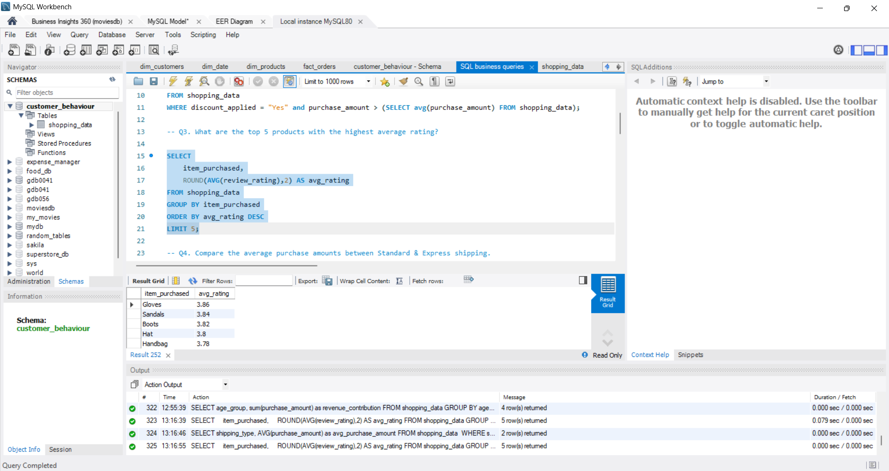
The screenshot below shows one of the SQL business queries executed in MySQL Workbench along with its result table.
5. Power BI Dashboard Summary
――――――――――――――――――――――――――――――――――――――――――――――――――――――――――――――――――――――――――――――――
The Power BI dashboard turns the analysis into a business-ready view. It highlights top KPIs at the top, category performance in the center, and age-group contribution at the bottom. Slicers on the left make it easy to filter by subscription status, gender, category, and shipping type.

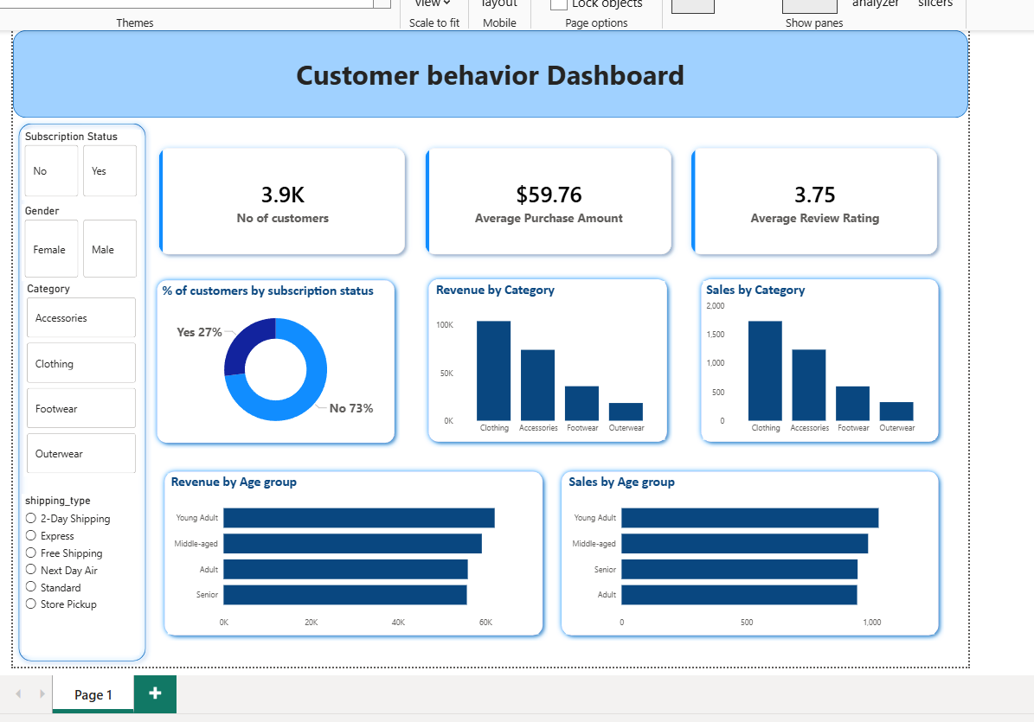
Figure 2. Power BI dashboard snapshot showing KPI cards, category performance, subscription mix, and age-group analysis.

Dashboard strengths:
• Clear KPI cards for number of customers, average purchase amount, and average review rating.
• Simple category comparisons that immediately show Clothing as the strongest line.
• Helpful slicers for interactive analysis without cluttering the main visuals.
• A clean blue visual theme that keeps the report consistent and readable.

6. Business Recommendations
――――――――――――――――――――――――――――――――――――――――――――――――――――――――――――――――――――――――――――――――
1. Prioritize Clothing in marketing, stock planning, and promotional campaigns because it is the top revenue category.
2. Use targeted retention offers for repeat buyers and convert high-frequency shoppers into subscribers.
3. Test selective discounts on products with strong discount sensitivity instead of applying discounts uniformly.
4. Focus on customer experience improvements for lower-spending segments so they can move toward higher-value behavior.
5. Promote the best-rated products more aggressively because strong rating usually supports trust and repeat buying.
6. Use gender and age-group insights to personalize campaigns rather than sending the same message to all customers.

7. Conclusion
―――――――――――――――――――――――――――――――――――――――――――――――――
This project combines Python, SQL, and Power BI into a single customer behavior analysis workflow. It turns raw transaction data into practical insights for revenue growth, retention strategy, product planning, and dashboard-based decision making.

